Final Project Requirements Document
Indicate what you have done and what pages and line numbers do these requirements reside (for all the questions, indicate yes if you completed or no if you did not complete it)
- Home page and at least 5 content pages (6 pages or more total)
Yes, the site includes 8 total pages: index.html, shop.html, about.html, contact.html, confirmation.html, product1.html, product2.html, and product3.html.
- A single external CSS file controlling styles across the site (internal and embedded styles may also be used when appropriate)
Yes, each HTML page links to the same external CSS file: <link rel="stylesheet" href="style.css">. This appears in the head section of the pages, such as index.html line 7, shop.html line 7, about.html line 7, and contact.html line 7. The CSS rules are in style.css.
- Consistent "look and feel" throughout the site (logo, color scheme, layout, navigation)
Yes, the site uses a consistent dark onyx/gray background, bronze/gold accent color, matching header, navigation, hero image area, buttons, tables, forms, and footer. These styles are controlled in style.css, including body colors lines 7–13, header styles lines 38–49, navigation styles lines 78–105, hero styles lines 109–136, main layout lines 140–147, and footer styles lines 354–365.
To pay more attention to detail the logo that displayed on the home page as its on image in the body to show it, and then it shows in the top right corner of all the remaining pages.
- Consistent navigation throughout the site
Yes, the navigation menu appears consistently on the pages with links to Home, Shop, About, and Contact. For example, it appears in index.html lines 19–26, shop.html lines 21–28, about.html lines 21–28, contact.html lines 21–28, and product pages such as product1.html lines 21–28.
- Use at least three images in addition to a logo (images should have alternate text) Where are the images? What files are they located in and where are the lines of code?
Yes, images with alt text are used throughout the site. Examples include IronHideLeatherBckgrnd.png in index.html lines 28–30, Creator.PNG in about.html line 38, LeatherTools1.PNG in about.html line 49, product images in shop.html lines 54, 68, 83, 97, and 111, and wallet images in product1.html lines 40–41, product2.html lines 40–41, and product3.html lines 40–42.
- Include at least three external links. Where are the external links? What files are they located in and where are the lines of code?
Yes, external links include Instagram in contact.html line 39, the leather crafting history article in about.html lines 59–61, and the Amazon leather tools kit link in shop.html line 122. Instagram is also linked to the product pages.
- At least one HTML list (ul, ol, or dl) element. Where are the HTML list elements? What files are they located in and where are the lines of code?
The navigation menu uses an unordered list in multiple files, such as index.html lines 19–26. Product feature lists also use unordered lists, such as product1.html lines 52–58, product2.html lines 52–58, and product3.html lines 53–59.
- At least one HTML table element. Where are the table elements? What files are they located in and where are the lines of code?
Yes, the shop page includes a product table. The table begins in shop.html line 43 and continues through line 125. It includes product images, wallet style, description, price, and product links.

- At least one HTML form element w/script for processing form data. Where is the form? What file or files are they located in and where are the lines of code?
Yes. The custom order form is on contact.html. The form begins at the <form> element and uses onsubmit="return processForm();" to run a JavaScript function before submission. The JavaScript script is located near the bottom of contact.html before the closing </body> tag. The script validates the name and email fields, displays a confirmation alert, and then sends the user to confirmation.html.
- Use of Search Engine Optimization (SEO) principles. Where are the lines of code that implement SEO?
Yes, basic SEO is included through descriptive page titles, semantic headings, meaningful page content, and image alt text. Examples include the <title> tag in index.html line 6, viewport meta tag in line 5, heading structure in lines 14–15 and 35, and descriptive image alt text in lines 28–30 and 38. Other pages also use descriptive titles, such as shop.html line 6, about.html line 6, and contact.html line 6.
- Mobile-friendly and/or fluid layout for different screen sizes. What lines and what files?
The HTML pages include the viewport meta tag, such as index.html line 5 and other pages line 5. The CSS includes fluid widths and responsive styling, including main { width: 90%; max-width: 1100px; } in style.css lines 140–147 and the mobile media query beginning at line 369. The mobile rules adjust the header, logo, navigation, hero area, main content, welcome layout, about columns, form, table, product images, and product buttons from lines 369–471.

- HTML and CSS passes validation test at W3Schools. You will need to include all of your screenshots of the HTML and CSS validations.

The HTML and CSS files have been tested and pass validation. See screen shots below.
CSS Validation -
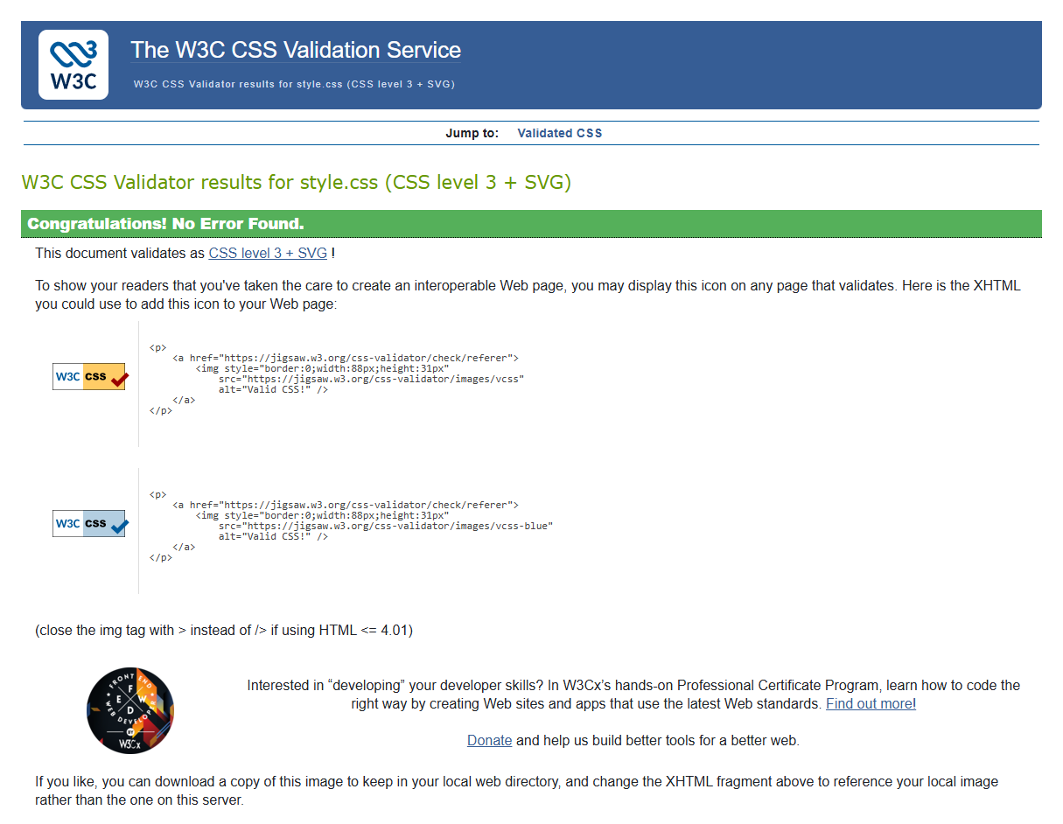
Index.html Validation -
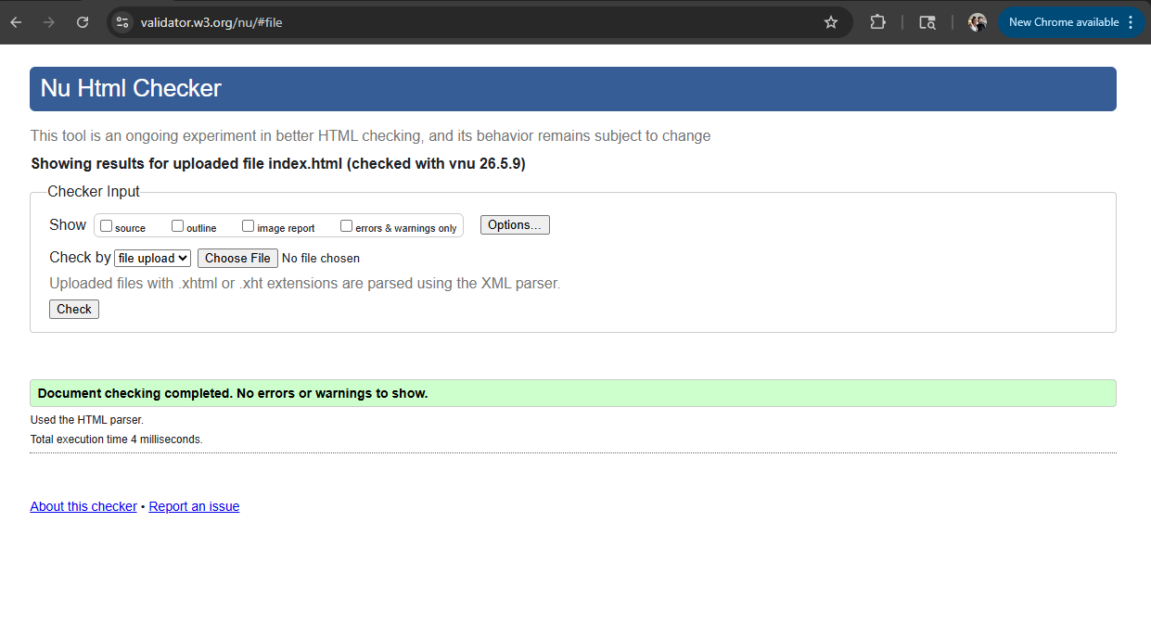
Shop.html Validation - 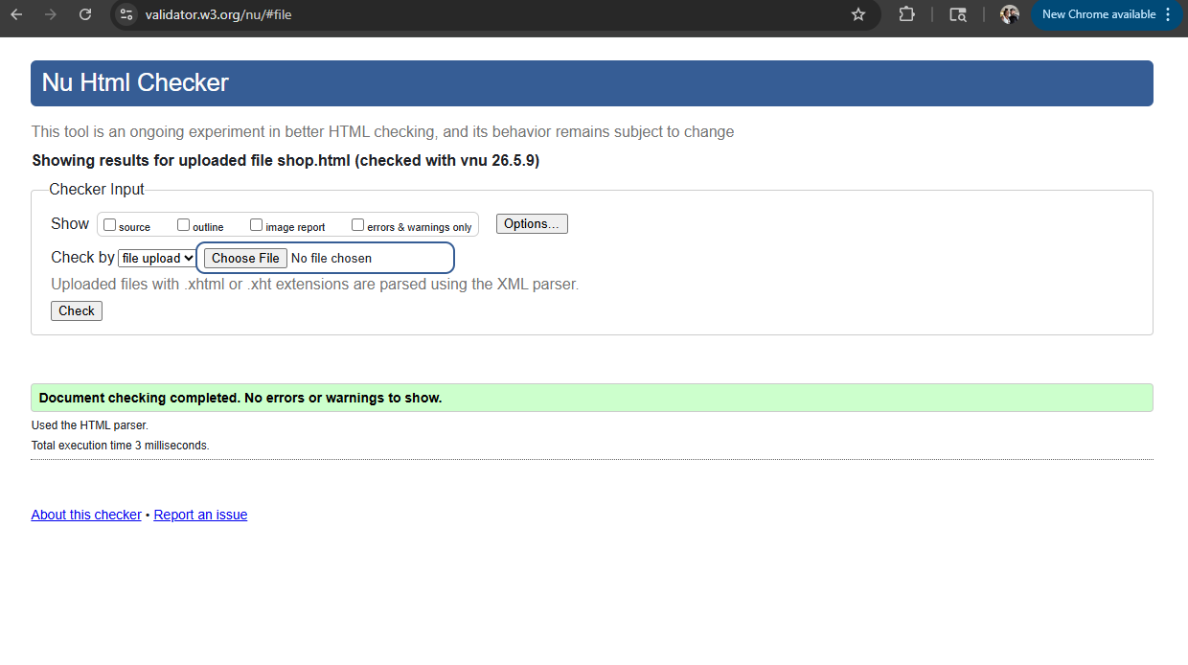
About.html Validation - 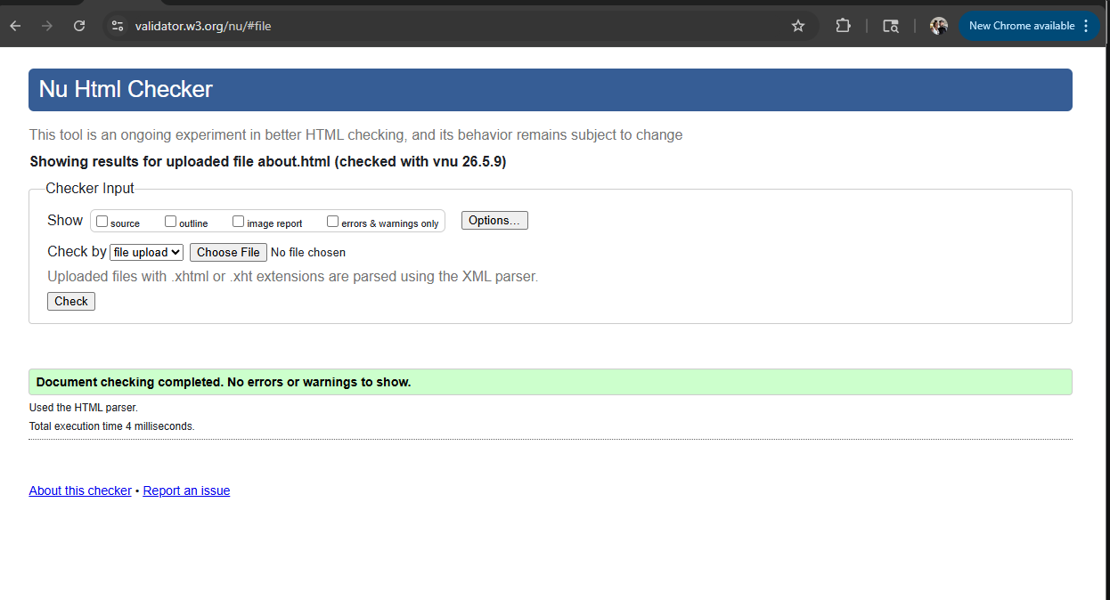
Contact.html Validation - 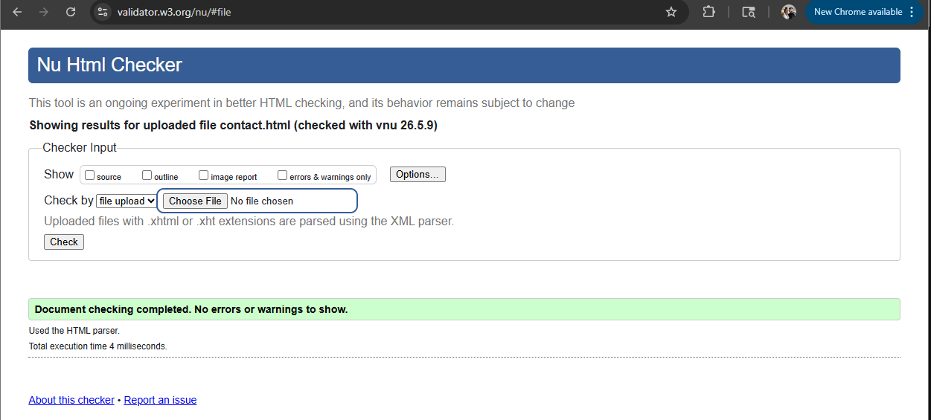
Confirmation.html Validation - 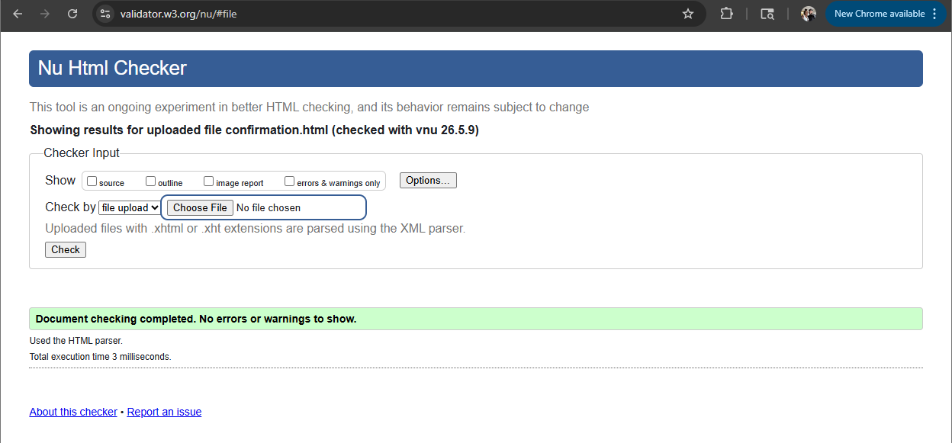
Product1.html Validation
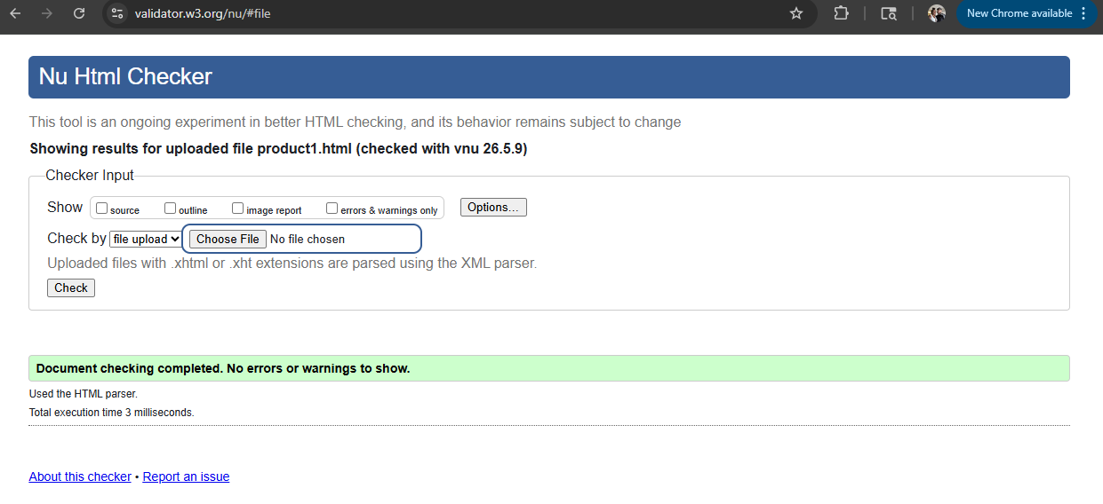
Product2.html Validation

Product3.html Validation


